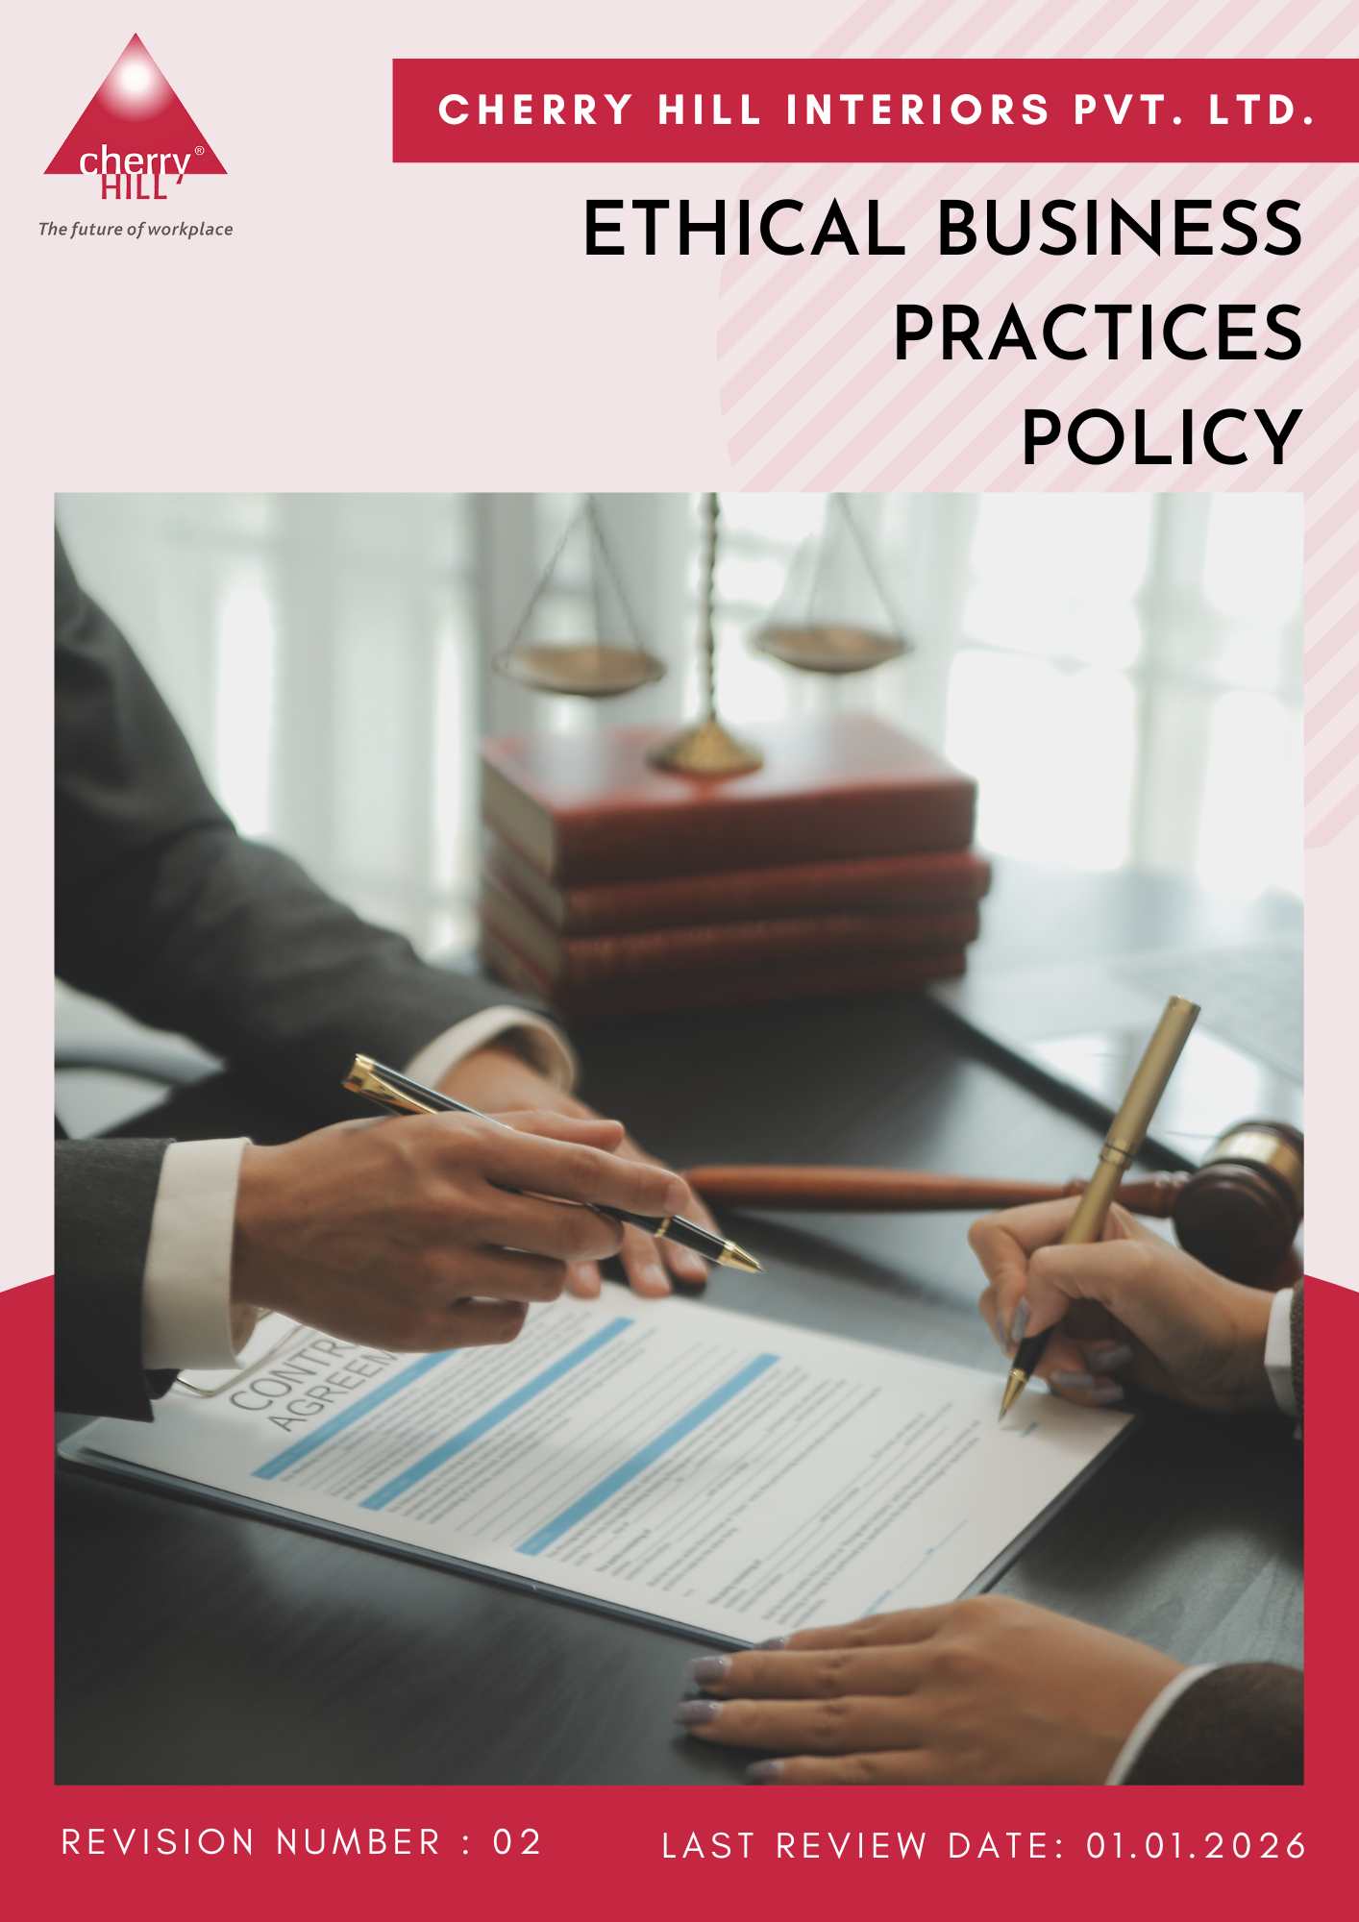

Contents
Preface 3
Scope 3
Policy Declaration 4
Key Action Areas 4
Qualitative Objectives 5
Targets based on our action areas 6
Examples and Guidance 7
Continuous Improvement: 8
Addressing Policy Violations: 9
Responsibility 10
Alignment with SDGs: 10
Review Mechanism: 11
Employee Acknowledgment Form 12

Preface
Cherry Hill Interiors Pvt. Ltd. is a prominent provider of occupancy solutions across India, specializing in corporate office interiors, healthcare facilities, and hospitality projects. Our operations are guided by strict compliance with legal and regulatory frameworks, ensuring fairness in business dealings and promoting responsible corporate behavior. Through proactive measures, continuous training, and ethical governance, we strengthen trust among employees, clients, and stakeholders. Our commitment to ethical business practices is rooted in integrity, transparency, and accountability. We strive to prevent corruption, fraud, conflicts of interest, and unethical conduct while ensuring compliance with all legal and regulatory requirements. By fostering a culture of honesty, fairness, and respect, we integrate responsible business conduct into our operations, promoting trust and ethical excellence across our stakeholder network.
Scope
This policy applies to all business operations, including office spaces, project sites, supply chains, and interactions with stakeholders. It extends to employees, contractors, suppliers, and partners engaged in our business activities.
Sr. No. |  | Locations | Address
1. | Cherry Hill Interiors Pvt. Ltd. (CHIPL) | Delhi (Head Quarter) | Y-33, Okhla Industrial Area, phase-II, New Delhi, India - 110020.
2. |  | Bengaluru (Branch Office) | First floor, no 1, 14th a Main, Hall 2nd Stage, Bangalore, Karnataka, India - 560008
3. |  | Chennai (Branch Office) | GN Chetty Road, Anmol Palani, 88, T Nagar, , Chennai, Tamil Nadu, India - 600017
4. |  | Pune  (Branch Office) | Liberty phase-2, Plot no. 323, Flat no.1, North Main Road, Koregaon Park, Pune, Maharashtra, India - 411001
5. |  | Hyderabad (Branch Office) | Third floor, Sreshta Marvel, Sy no 136, Gachibowli Konadpur Main Road, Gachibowli, Hyderabad, Telangana, India - 500032
6. |  | Factory | Plot no. 81-a, sector-5, IMT Manesar, Gurugram, Haryana, India - 122050
NOTE: The Ahmedabad, Kolkata, and Sri Lanka sites are not operational, and less than 1% of employees are from this location out of the total.
Policy Declaration
Ethical responsibility and inclusivity form the foundation of Cherry Hill Interiors Pvt. Ltd.’s workplace culture. With Year 2022 as the baseline year for all our targets, we ensure adherence to ethical business practices, compliance with legal and industry standards, and responsible stakeholder engagement. Through governance, training, and collaboration, we continuously strengthen our ethical business conduct.
Key Action Areas
- Preventing Corruption and Unethical Practices: Anti-corruption measures, ethical conduct, and compliance with applicable laws.
- Managing Conflicts of Interest in Business Operations: Identification, disclosure, and management of actual or potential conflicts of interest.
- Strengthening Fraud Prevention and Detection Mechanisms: Controls and monitoring systems to prevent, detect, and address fraudulent activities.
- Preventing Money Laundering and Financial Crimes: Measures to mitigate risks related to money laundering and financial misconduct.
- Strengthening Information Security and Data Protection: Protection of information assets, cybersecurity, and personal data privacy practices.

Qualitative Objectives
- Preventing Corruption and Unethical Practices
- Promote a culture of integrity by conducting ethics and anti-corruption training annually for all employees.
- Review the confidentiality and accessibility of whistleblower mechanism for reporting corruption-related concerns.

- Managing Conflicts of Interest in Business Operations
- Implement a mandatory disclosure system where employees and business partners must report potential conflicts of interest.
- Maintain the strict enforcement of clear guidelines to prevent favoritism, nepotism, and undue influence in business dealings.

- Strengthening Fraud Prevention and Detection Mechanisms
- Maintain strict implementation of zero-tolerance policy for fraudulent behavior with clear disciplinary measures and enforcement protocols.
- Enhance internal controls and financial oversight mechanisms to prevent, detect, and mitigate fraudulent activities.

- Preventing Money Laundering and Financial Crimes
- Strengthen financial monitoring systems to detect and report suspicious transactions in accordance with regulatory guidelines.
- Ensure compliance with anti-money laundering (AML) regulations through continuous updates and mandatory training for relevant teams.

- Strengthening Information Security and Data Protection
- Ensure strict implementation of advanced cybersecurity measures to safeguard sensitive business, employee, and client data from breaches.
- Regularly update IT security protocols to address evolving cyber threats and ensure compliance with industry best practices.
- Conduct annual employee training on data privacy, phishing prevention, and cybersecurity risk management.

Targets based on our action areas
- Preventing Corruption and Unethical Practices
- Ensure that 100% of supplier and business partner contracts include anti-bribery and anti-corruption clauses by year 2028.
- Investigate and take corrective action if required on 100% of corruption-related reports within 30 days of receipt.
- Maintain zero confirmed incidents of corruption identified through internal or external audits on an annual basis till year 2028.
- Ensure 100% of employees, suppliers, and contractors in high-risk roles receive annual anti-corruption training till year 2028.

- Managing Conflicts of Interest in Business Operations
- Achieve 100% completion of conflict-of-interest declarations by all managers, key decision-makers, and Board members by year 2028.
- Address and resolve 100% of reported conflict of interest cases within 45 days, ensuring appropriate actions are taken by year 2028.

- Strengthening Fraud Prevention and Detection Mechanisms
- Maintain zero reported fraud incidents through improved controls and awareness programs by year 2028.
- Ensure 100% financial transactions above a defined threshold undergo independent verification before approval.
- Review and strengthen fraud detection mechanisms and internal controls to cover 100% of critical processes by year 2028.

- Preventing Money Laundering and Financial Crimes
- Train 100% of finance, procurement, and compliance teams on AML regulations and financial crime prevention annually.
- Conduct two internal AML audits covering 100% of relevant business units to identify and mitigate AML-related risks by year 2028.
- Implement automated transaction monitoring for all financial dealings by 2028, enabling real-time detection of suspicious activities and reducing the risk of money laundering.

- Strengthening Information Security and Data Protection
- Implement end-to-end encryption or equivalent secure encryption protocols for 100% of systems handling sensitive company and customer data by year 2028.
- Ensure 80% of employees complete data protection and cybersecurity awareness training by year 2028 and annually thereafter.
- Ensure 100% compliance with information security audits conducted annually across all departments by year 2028.
- Maintain zero incidents of unauthorized data access and breaches through improved controls by 2028.
Examples and Guidance
To support consistent understanding and implementation of this Ethical Business Practices Policy, the following topic-wise examples and guidance offer practical interpretations of expectations and actions:
- Anti-Corruption
- Example: A supplier offers a cash incentive or expensive gift to a company employee in exchange for influencing a tender decision.
- Guidance: The employee must refuse the offer and immediately report it to the Compliance Officer. Accepting or ignoring such offers violates the Cherry Hill’s zero-tolerance policy on bribery and undermines fair competition.
- Conflict of Interest
- Example: A manager is involved in selecting a vendor where a close family member has a financial interest.
- Guidance: The manager must disclose the conflict immediately and recuse themselves from the decision-making process to ensure objectivity and transparency.
- Fraud Prevention
- Example: An employee alters expense claims or financial records to receive reimbursement for personal expenses.
- Guidance: Such conduct is strictly prohibited and must be reported to Finance or Compliance for investigation. Fraud damages trust, violates company policy, and may lead to disciplinary and legal action.
- Anti-Money Laundering (AML)
- Example: A client requests breaking a large wire transfer into smaller payments to avoid regulatory reporting.
- Guidance: This is a potential money laundering red flag. The transaction must be reported and reviewed according to AML procedures. Employees must be trained to recognize and respond to suspicious financial behavior without delay.
- Information Security
- Example: An employee shares confidential business data or customer information with an unauthorized third party or through unsecured email.
- Guidance: Confidential and personal data must only be shared through approved secure channels and with authorized persons. Any suspected data breach must be reported immediately to IT or Compliance.
Continuous Improvement:
At Cherry Hill, Ethical Conduct practices are continuously enhanced to stay aligned with evolving regulations, industry standards, and emerging risks. A strong culture of integrity is embedded across all levels of the organization, ensuring transparency, accountability, and regulatory compliance.
- Ongoing Training & Awareness: Cherry Hill conducts regular ethics, anti-corruption, AML, fraud prevention, and data protection training for employees and relevant external stakeholders. Training programs are updated periodically to reflect regulatory changes, emerging risks, and lessons learned from internal reviews and incidents.
- Risk Assessments & Independent Audits: Periodic ethics and compliance risk assessments are carried out to identify potential vulnerabilities related to corruption, fraud, conflicts of interest, money laundering, and information security. Independent internal and external audits are used to validate controls, verify compliance, and recommend improvements.
- Collaborative Compliance Engagement: Partnerships with internal and external stakeholders strengthen ethical standards and compliance through structured assessments, engagement, and continuous improvement actions.
- Advanced Monitoring & Reporting Systems: The company maintains systems to monitor high-risk transactions, compliance indicators, incidents, and policy adherence. Key metrics are reviewed regularly by management to ensure early detection of risks, timely response, and continuous strengthening of controls.
- Feedback & Transparency Culture: Cherry Hill encourages open feedback, ethical dialogue, and reporting of concerns without fear of retaliation. Whistleblowing and grievance mechanisms are promoted actively, and aggregated findings and improvements are communicated transparently to reinforce trust and accountability.
Addressing Policy Violations:
We at Cherry Hill Interiors Pvt. Ltd. enforces a zero-tolerance approach to ethical violations, including corruption, conflicts of interest, fraud, money laundering, and information security breaches. Strict corrective actions are taken to uphold integrity.
- Reporting Mechanism: Employees, suppliers, and stakeholders can report suspected violations through the confidential whistleblower system. Reports may be anonymous and are handled with strict confidentiality to prevent retaliation.
- Investigation & Disciplinary Actions: The Compliance Officer investigates all reports, involving internal teams or external auditors as needed. Violators face disciplinary actions, including warnings, suspension, termination, or legal proceedings. Suppliers found in breach may face contract suspension or blacklisting.
- Corrective & Preventive Actions: Remedial measures, such as process improvements, additional training, or stronger controls, are implemented to prevent recurrence. Findings from major breaches inform future risk assessments to strengthen policy enforcement.
- Protection from Retaliation: Retaliation against any individual who reports concerns in good faith or participates in an investigation is strictly prohibited. Any act of retaliation will be treated as a serious policy violation and subject to disciplinary action.
Responsibility
A strong ethical culture requires accountability at all levels of the organization. The following roles are responsible for upholding and enforcing this policy:
- Senior Management ensures ethical business practices and regulatory compliance across all operations.
- The Compliance Officer oversees policy implementation, training, and investigations.
- Department Heads and Supervisors ensure ethical standards are integrated into daily operations.
- Finance and Procurement Teams conduct due diligence to mitigate corruption, fraud, and money laundering risks.
- All Employees adhere to ethical standards, report violations, and complete mandatory training.

Alignment with SDGs:


Review Mechanism:
- The Ethics Officer reviews this policy once after every two years or earlier in response to regulatory changes, emerging risks, or operational needs.
- Findings from risk assessments, internal audits, employee feedback, and reported ethical concerns are evaluated to enhance policy effectiveness.
- Necessary revisions are implemented, and updated policies are communicated to all employees, suppliers, and relevant stakeholders to ensure continued compliance and awareness.

Last Review Date | : 01.01.2026
Next Review Date | : 01.01.2028
Approved By | :

Employee Acknowledgment Form
I acknowledge that I have received, read, and understood the Ethical Business Practices Policy of Cherry Hill Interiors Pvt. Ltd. I agree to uphold the principles outlined in this policy, including preventing corruption, managing conflicts of interest, combating fraud, ensuring compliance with anti-money laundering regulations, and safeguarding information security.
I understand that it is my responsibility to adhere to this policy in all professional activities and to report any ethical concerns or violations through the designated reporting channels. I acknowledge that non-compliance may result in disciplinary action in accordance with company regulations.
By signing this acknowledgment, I confirm my commitment to integrity, transparency, and ethical conduct in all aspects of my work.

Employee Name  Employee ID  Date  Signature | : _______________________________  : _______________________________ :________________________________  : _______________________________

